Automated External Defibrillators (AED’s)

AEDs are used to restore a normal heart rhythm in people in cardiac arrest. AEDs analyse the heart rhythm and if a shockable rhythm is detected, the AED will administer a high energy electric shock to the heart to restore a more stable rhythm. AEDs will not shock hearts where the heart rhythm is normal, they will also not shock hearts where there is no electrical activity present at all. We call this asystole or sometimes referred to as ‘flatlining’

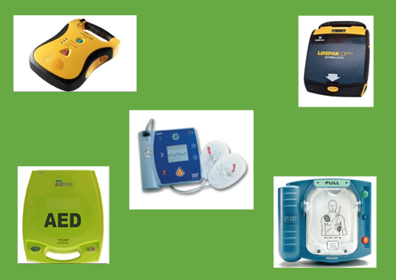
AEDs are designed to be used by people with no prior training. They are simple and safe to use and are found in public spaces like shops, leisure centres, airports, railway stations, shopping malls, village halls etc. AEDs don’t all look the same but function in similar ways and give clear, verbal instructions.

Some public access defibrillators are registered with the ambulance service but not always so it is a good idea to find out where your nearest AED is located. We know AEDs are key to OHCA (Out of hospital cardiac arrest) survival rates. After a cardiac arrest, every minute that passes without CPR and defibrillation reduces the chances of survival by 10%. Crucially the best survival rates occur where AEDs are used within 3-5 minutes after the cardiac arrest has occurred.

How to use an AED
- Minimise interruption to CPR – if you have a helper, ask them to continue CPR while you get the AED ready
- Switch the machine on immediately and follow the voice prompts
- Expose the patients bare chest –quickly cut away clothing, dry if wet and shave if hairy so the pads will attach properly. (a towel, scissors and razor should be stored with the AED)
- Place the pads in the correct position – following the instructions on the pads.
- Plug in the pad connector at the flashing light
- The AED will now analyse the heart rhythm – at this point it is important no one is touching the casualty, otherwise the AED will pick up the heart rhythm of the person touching the casualty. Tell everyone to ‘stand back – do not touch the patient’ Stop CPR whilst the AED analyses the heart rhythm.
- If a shock is required, instruct any bystanders to ‘stand back, do not touch the patient’ before pressing the flashing shock button. As soon as the shock has been delivered, resume CPR.
- If no shock is required continue with CPR
- Continue as directed by the voice prompts. If the heart rhythm is not corrected, the AED will analyse the heart rhythm again after 2 minutes. Continue as directed by the voice prompts until emergency medical assistance arrives.
- If breathing is restored, leave pads in place. Check airway and breathing and roll the casualty into a safe airway position. Monitor closely as it is possible they could go back into cardiac arrest. Reassure the casualty and keep them warm.

AED safety considerations:

Electric shocks: Recent tests have shown that if the casualty’s chest is dry and the pads are stuck to the chest correctly then the risk of electrical shock is low. DO NOT delay defibrillation if the casualty is lying on a wet or metal surface. Providing the chest is dry, it is safe to deliver the shock.

Jewellery: DO not place pads over jewellery as this could conduct the electricity and burn the casualty. Move jewellery to one side if possible but do not waste time removing pierced jewellery

Medication Patches: Some medication patches such as GTN patches ( for relieving Angina symptoms) can explode if electricity is passed through them. So remove any visible patches as a precaution if possible.

Implanted Devices: Implanted devices such as pacemakers or defibrillators are usually implanted just below the left collarbone which is not in the way of AED pads but if a device has been implanted elsewhere avoid placing the pad directly over it.

Flammable atmospheres: There is a risk an AED may create a spark when delivering a shock. For this reason do not use AEDs in highly flammable environments such as a petrol station forecourt. You will need to move the casualty away from areas if they are high risk.

Inappropriate shock: AEDS are extremely accurate at analysing heart rhythms but to do so the casualty must be motionless. Do not use an AED on a casualty who is fitting and ensure vehicle engines and vibrating machinery is switched off.

Swift First Aid
June 2020

