Cardiac Arrest & CPR (LO 3.1, 3.2)

The heart has an electrical system that regulates the heart beat and keeps oxygenated blood circulating around the body. If there is a malfunction in this electrical system it causes an irregular heart rhythm and stops blood being pumped around the body. This abnormal rhythm can result in the heart quivering rapidly called Venticular Fibrillation or there may be no heartbeat at all, known as Asystole.

As the heart stops pumping oxygenated blood around the body, the brain is starved of oxygen. This causes the person to fall unconscious and stop breathing. When someone is unresponsive and not breathing normally, we say they are in CARDIAC ARREST

Common causes of Cardiac Arrest are heart attacks caused by Coronary Heart Disease and inherited heart conditions but Cardiac Arrest can also be caused by drug overdoses, severe blood loss and hypoxia (severe drop in Oxygen levels) eg drowning, strangling, choking, smoke inhalation, trauma and electrocution.

Cardiac Arrest usually happens without any warning. If someone is in cardiac arrest, they will collapse suddenly and will be unresponsive and won’t be breathing or not breathing normally. They may be making gasping sounds and their skin will be blue/grey in colour
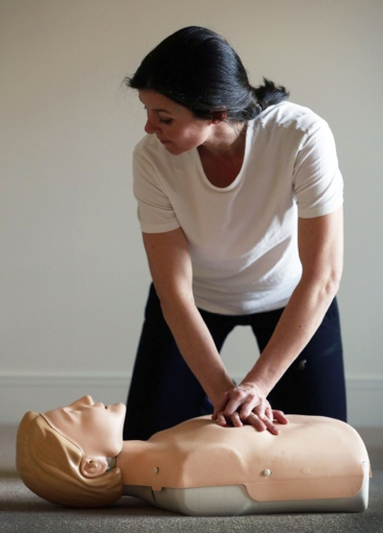

Without immediate treatment, the casualty will die. As soon as we recognise a person is in cardiac arrest
- dial 999 immediately – activate speaker function on phone
- Start CPR – this is vital as it keeps blood and oxygen circulating to the brain and around the body
- If there is an AED (Automated External Defibrillator) nearby send someone to get it. This could restore a normal heart rhythm and get the heart beating again
- Minimise CPR interruption when attaching AED pads.

CPR – Cardio Pulmonary Resuscitation
CPR is an emergency procedure performed in an effort to preserve brain function until further measures are taken to restore blood circulation and breathing in a person who is in cardiac arrest. It is a way of manually pumping the heart and maintaining a supply of oxygen to the brain until further interventions can take place to restore a normal heart rhythm.

CPR is a combination of 30 chest compressions and 2 rescue breaths performed without interruption until help arrives or until the casualty starts to breathe again.

To carry out a chest compression:
- Place the casualty on a firm surface
- Kneel close alongside the casualty’s abdomen
- Place the heel of your hand mid-point between the armpits and above the sternum. Place your other hand on top of your first hand and interlock your fingers.
- Position yourself with your shoulders above your hands and your arms straight.
- Using your body weight (not just your arms), press straight down by 5-6 cm (2-2.5 inches) on their chest.
- Keeping your hands on their chest, release the compression and allow the chest to return to its original position.
- Repeat these compressions at a rate of 100 to 120 times per minute 30 times.

To carry out a rescue breath:
- Tilt the casualty's head gently and lift the chin up with two fingers. Pinch the person’s nose. Seal your mouth over their mouth and blow steadily and firmly into their mouth for about one second. Check that their chest rises. Give two rescue breaths in no more that 5 seconds
- Continue with cycles of 30 chest compressions and two rescue breaths until they begin to recover or emergency help arrives.

3 cycles of CPR should take about 1 minute.

Things to consider
- Use a face shield or pocket mask for rescue breaths to reduce the risk of cross infection if the casualty has blood or vomit around the mouth.
- If you are uncomfortable doing rescue breaths concentrate on good quality chest compressions
- If you are concerned the person may be Covid-19 positive, DO NOT do rescue breaths and place a loose covering over their face eg a towel or scarf
- If the casualty vomits, roll them away from you to allow the vomit to drain, wipe the face clean and continue CPR
- If there are bystanders or someone is with you, get them to help you with CPR to prevent fatigue – change every 2 mins (about 6 cycles of CPR)
- Only stop CPR if a health professional tells you to stop, you become exhausted, an AED arrives or the casualty is definitely waking up, moving, opening their eyes and breathing normally.

It is unlikely CPR alone will restore a casualty’s breathing, unless the casualty has been starved of oxygen eg if they have drowned. Generally we need access to an AED to maximise the chances of survival. However if the casualty does start to breath and regain consciousness, stop CPR, do your DRS ABC and roll the casualty into a safe airway position. Monitor closely as it is possible the casualty could go back into cardiac arrest.

The CPR protocol for children and infants is slightly different. If you forget then use the adult protocol instead. Doing something is better than doing nothing.

With children, it is very unusual for them to go into Cardiac Arrest as generally they do not have underlying heart conditions. More often than not if a child goes into cardiac arrest, it is because they have been starved of oxygen eg they have drowned or asphyxiated themselves through strangling or choking.

With children who are over 1 year old and under 14 years old – deliver 5 rescue breaths first and then perform 30 chest compressions to 2 rescue breaths until help arrives. If you are on your own perform 1 minute of CPR ie around 3 cycles of CPR before going for help. If the child is small you can use the heel of one hand rather than 2 when doing chest compressions.

With an infant who is under 1 year, use the same protocol but use 2 fingers only for the chest compressions. If the infant is very small seal both the nose and mouth with your mouth when delivering rescue breaths.

If an AED is available use it. AED’s can restart hearts in up to 80% of cases. Hearts in cardiac arrest are unlikely to re-start with CPR alone.

Swift First Aid
June 2020

