First Aid Equipment (LO 1.1)

Your first aid kit should be based on your first aid needs assessment so consider what types of injuries are most likely to occur in your workplace and stock your first aid kit accordingly.

If you are buying a kit look for British Standard (BS) 8599. By law your kit does not have to meet this standard but you should check if it contains what you’ve identified in your needs assessment

First Aid kits should only contain FA equipment, be visible and easily accessible
Contents should be checked regularly for expiry dates
All dressings need to be individually wrapped and sterile
Contents should be protected from dust and damp

As a guide, where work activities are low-risk a minimum first aid kit might contain:
- A leaflet/manual with general guidance on first aid
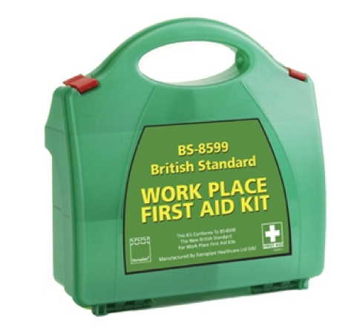
- Individually wrapped sterile plasters of assorted sizes
- Sterile eye pads
- Individually wrapped triangular bandages
- Safety pins
- Large and medium sized individually wrapped, unmedicated wound dressings
- Disposable gloves
- Tough cut scissors
- Alcohol free cleaning wipes
- Face shield/pocket mask
- Tweezers
- Sterile eyewash

First Aid kits should NOT include sprays, antiseptic wipes, creams, lotions, tablets or medication

Consider any additional equipment that may be useful to have eg foil blankets, disposable aprons, blankets, mobile first aid pouches, AED and equipment for treating catastrophic bleeds if you work in a high risk environment eg forestry, gamekeeping, premises using cutting machinery.

Swift First Aid
June 2020
