Minor Injuries (LO 7.1, 7.2)

Minor injuries tend to be the ‘bread and butter’ work for first aiders. They can usually be treated in the workplace rather than in hospital. With this in mind always ensure your first aid kit is stocked with the equipment required for treating the most common types of injuries you are likely to treat in your workplace.

Small cuts & grazes
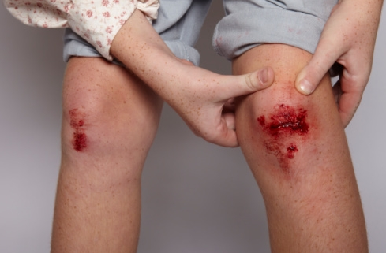
- Ask: What happened? Do you want some help with that?
- Consider cross infection: always wear gloves if available
- Clean with water or a sterile wipe
- Cover with an appropriate dressing

Bruises

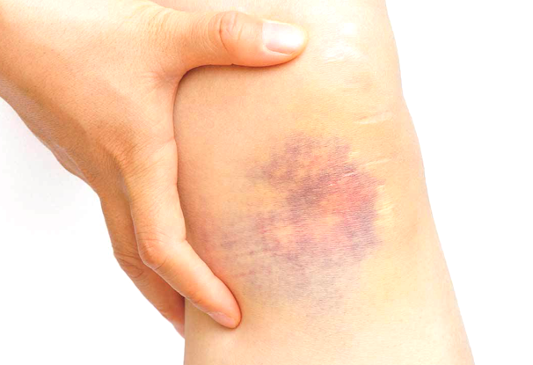
- Ask: What happened? Do you need some help?
- Apply a cold compress to the injury site. Apply for a maximum of 10 minutes and repeat every hour to reduce swelling. If using ice, wrap the ice in a tea towel to avoid damaging sensitive tissue
- Advise rest and elevate if necessary (ankle & lower limb bruising)

Small Splinters

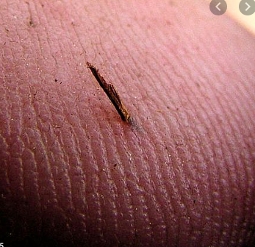
- Ask: What happened? Do you need some help with that?
- Pull splinter out using tweezers
- Squeeze gently to encourage wound to bleed a little which helps to flush out any dirt
- Clean with sterile wipe and cover if necessary
- If the splinter cannot be removed, do not probe using needles etc. Advise person to attend GP or minor injuries unit.
- If the area becomes inflamed, red, sore and appears infected advise person to get advice from NHS 111.

Minor burns and scalds

- Ask: What happened? Do you need some help?
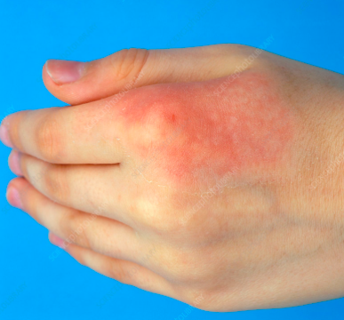
- Cool the burn immediately by holding the affected area under cool, running water for a minimum of 10 minutes or until the pain starts to subside. If water is not available you can also use any cool liquid such as milk.
- Remove any jewellery that may constrict circulation if the affected area swells such as rings and bracelets
- Remove clothing over the affected area but if stuck to the skin DO NOT attempt to remove – cool the burn through the clothing instead
- Cover the burn loosely with a non-adherent dressing or with cling-film – discard the first few turns.

DO NOT:
- Cool burns using ice
- Burst blisters as this can introduce infection
- Use creams or ointments
- Use adherent dressings as this can tear the skin when removed

Assessing the severity of a burn: When to seek further medical advice.

- Burns larger than 1% of the persons body area (1% equals the size of the hand including fingers)
- All chemical and electrical burns – wash chemicals off the skin using running water for 20 minutes
- All children and the elderly
- Burns to face, hands, feet, genitals and burns than go right around a limb
- Full thickness burns – burn may appear charred or waxy. Damage to nerves may result in little or no pain being experienced.

Swift First Aid
June 2020
